Business Requirement Document

***Requirement ID ART_001***

***Title: B2C-Flight Module***

***Prepared by:*** *Sangeetha*

***Prepared for:*** *Al Rostamani Travels*

***Date Submitted:*** *09-Jul-2020*

***Document Number:*** *ART_001*

***Change History***

|  |  |  |  |
| --- | --- | --- | --- |
| Ver.# | Date | Author | Change Description |
| 1 | 09Jul20 | Sangeetha | Draft |
| 2 | 10Jul20 | Ajith | Review |
| 3 | 15Jul20 | Sangeetha | V2 Draft |
| 4 | 15Jul20 | Ajith | Review |
| 5 | 20Jul20 | Sangeetha | V3 Draft |
| 6 | 20Jul20 | Ajith | Review |
| 7 | 21Jul20 | Sangeetha | Final |

Table of Contents

1. INTRODUCTION: 4

2. FEATURE: 4

3. SEARCH FLIGHT: 5

3.1. Passenger selection condition message 6

3.2. Search Loading Mechanism 7

3.3. SEARCH RESULTS 7

3.4. MODIFY SEARCH 7

3.5. Flight details: 8

3.6. Search filters: 9

3.6.1. Filter by Stops: 9

3.6.2. Filter by Airlines: 9

3.6.3. Filter by Duration: 10

3.6.4. Filter by Fare Type: 10

3.6.5. Filter by Baggage: 11

3.7. Sorting Method: 11

4. REVIEW FLIGHT: 11

4.1. Itinerary details 11

4.2. Cabin Baggage: 12

4.3. Booking Flow: 13

4.3.1. Guest User: 13

4.3.2. Logged In User (Login from the Home page). 13

4.3.3. Guest User and Login from the Booking review screen: 14

5. Insurance Upsell 14

6. Travellers 15

6.1. National ID for Saudi Nationalities: 16

6.2. Provision to capture the Air miles Number in the Profile: 18

6.3. Special Services Request for GDS Flights: 18

6.4. Special Services Request for LCC Flights 21

7. Trip summary 23

8. Payment 24

8.1. Payment And Booking Confirmation Process:(GDS) 25

8.2. Process Flow: 25

8.3. Payment And Booking Confirmation Process:(LCC) 26

8.4. Successful booking scenario: 26

8.5. Failure case: 26

9. Booking Confirmation Page: 30

10. Approval 31

ART - Flight Module

# INTRODUCTION:

This document explains the functional flow of flight module. The flight module has below mentioned features.

# FEATURE:

* Search flight
* Search result- Choose flight
* Review flight
* Payment and booking

Login Process:

* The user shall be able to purchase a Flight as Registered logged in user or as a guest user

User ID Registration Process:

* + When the User clicks the Signup link or register link available on the home page, system shall allow the user to enter the email ID. After submitting the Email ID, the system shall send a registration link email to the Email ID, the user shall access the email link and proceeds with the registration completion and User ID activation process.
    - **Note:** Currently this process is available during the booking journey. Need the same process to be implemented for the Initial website registration process flow.
    - The user shall click the User ID registration activation email link and the user shall be redirected to the B2C system for completing the registration process.
* Registration Screen:
  + Option for the user to select (check box) -- Yes, I would like to receive email updates from Al Rostamani Travels. (like how it is mentioned in OUA website on the booking review page)

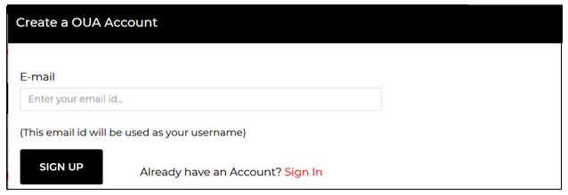

FIG 1. Registration screen

The check box "Yes I would like to receive email updates from Al Rostamani Travels" can be put on the registration screen.



# SEARCH FLIGHT:

In the “Search flight”, the user can search their flights by feeding required data in search screen.

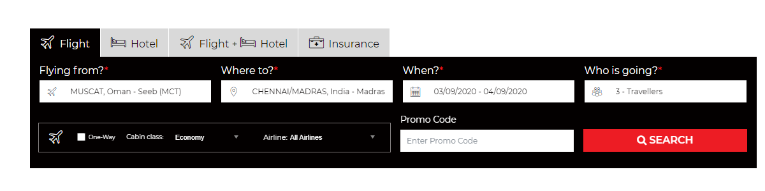

FIG 2. SEARCH FLIGHT SCREEN

# Passenger selection condition message

Next to the passenger count selection window a question mark icon shall be available. When the user mouse overs the icon, the system shall display the message as shown in the figure 15.

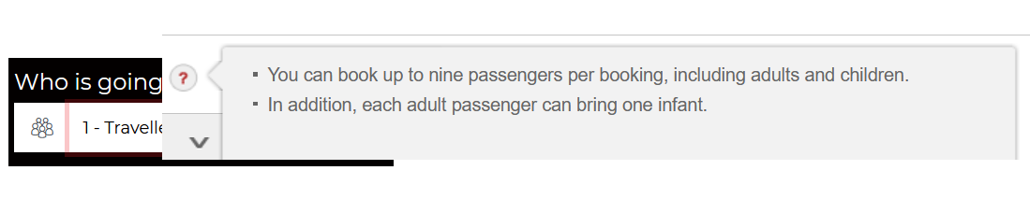

FIG 3: Passenger selection condition message

|  |  |  |
| --- | --- | --- |
| Fields | Field Type | Description |
| From Airport | Text Box(**TB)**,Mandatory**(M)** | The field should accept the Airport code and the city name. When the user enters the airport code, then the airport should be displayed. Auto population of airport name should be done on pressing the tab button. |
| To Airport | Text Box(**TB)**,Mandatory**(M)** | The field should accept the Airport code and the city name. When the user enters the airport code, then the airport should be displayed. Auto population of airport name should be done on pressing the tab button. |
| Date Selection | Calendar Field, Mandatory**(M)** | After clicking the calendar icon,The calendar should populate the from date and to date. And after selecting the dates, it should show the total duration of the selected dates.  **Calendar date selection should be restricted to 320 days (configurable according to the business rules)** |
| Passenger Field | Drop-Down**(DD)**, Mandatory**(M)** | This filed allows user to select the passenger type and count.**Passenger (Adult+Child) count should not together should not exceed 9** |
| Promo Code | Text Box(**TB)**, Optional**(O)** | Option to enter promo code |
| Cabin Class selection | Drop-Down**(DD)**, Mandatory**(M)** | Option to select cabin class |
| Trip type | Mandatory**(M)** | Option to select trip type(one way, round trip, multi city) |
| Preferred Airlines | Text Box(**TB)**, Optional**(O)** | Option to select preferred airline |
| Non Stop | Check Box**(CB)** | Option to select non stop flights |

# Search Loading Mechanism

Once the user searches, an intermediate search loading page shall be viewed with the searched data until the results are displayed. This page can be used for advertising as well. Once the system receives the response from the supplier, the system shall show all the Air results together (Max 15 seconds).

# SEARCH RESULTS

After feeding required data in search screen, when the user clicks search, the search results will be displayed.

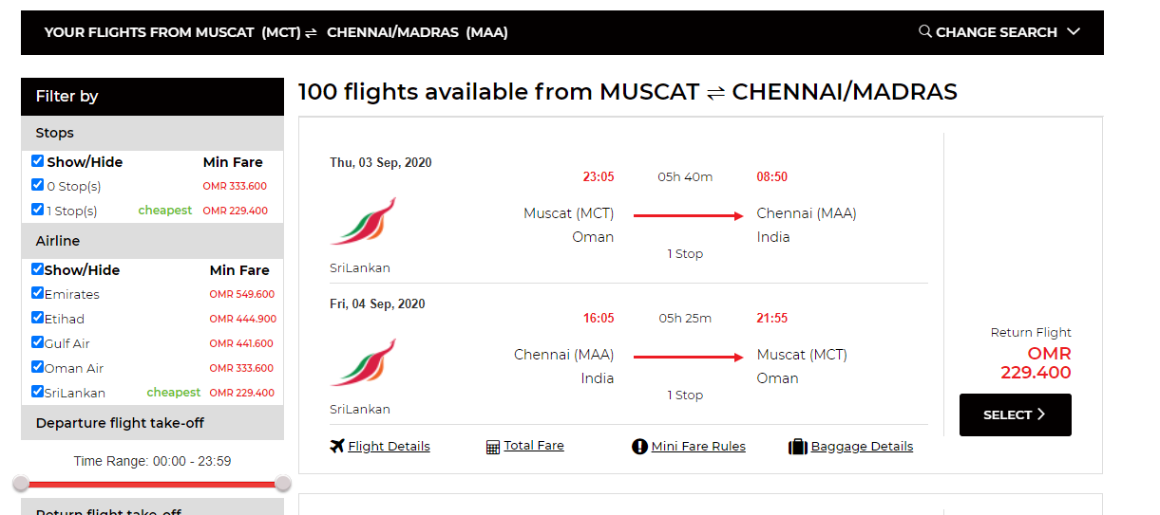

FIG 4. SEARCH RESULT SCREEN

# MODIFY SEARCH

This section allows the user to change their search criteria.

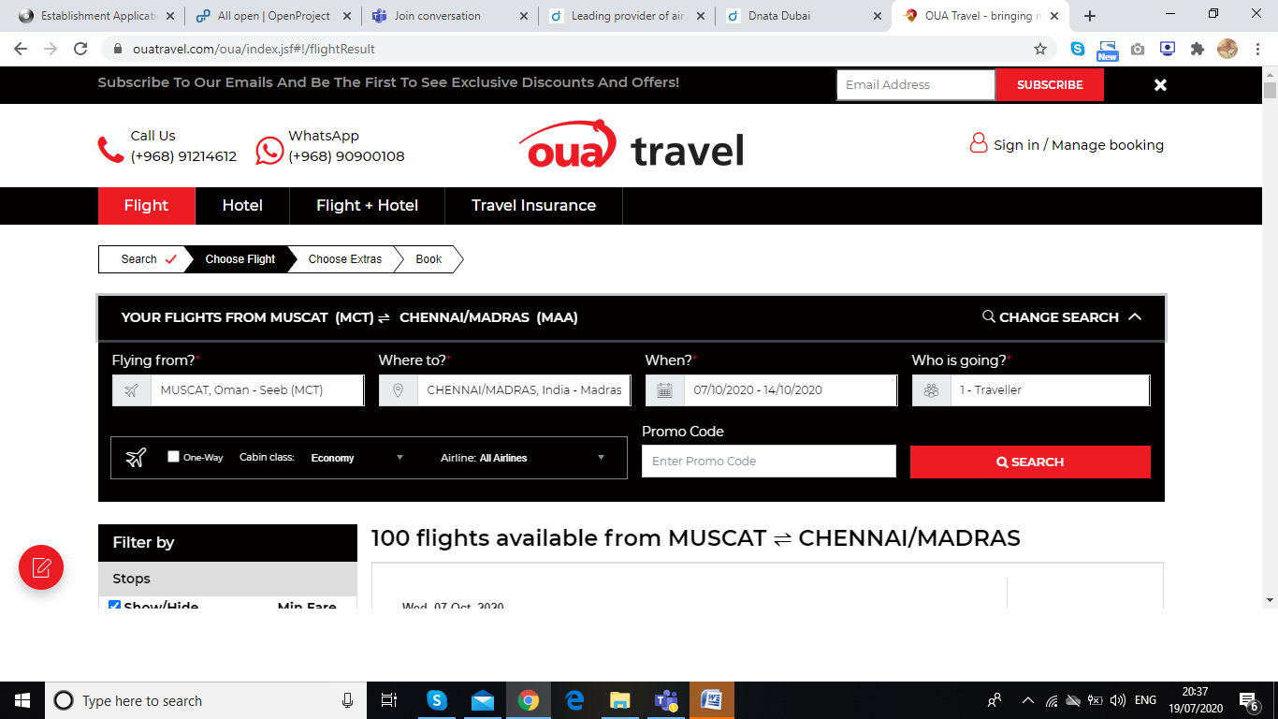

FIG 5. Modify search

# Flight details:

Need to have the details like Baggage (Cabin and Check-in-as mentioned in Fig3.1 below) Sector wise,Fare Type Refundable or non- refundable for each sector,Mini Fare rules link ( With ART given static text),Operated by Airline, Seat availability notification for both GDS and LCC, total fare,Bus icon next to the origin if it is a bus station. Example XNB.(FIG 3). Search results display should be like SATA in a compact display in appearance.

Fare breakup details not required to be shown in search result. Only total fare will be shown.

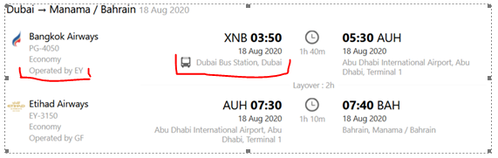

FIG 6. Search results with bus station

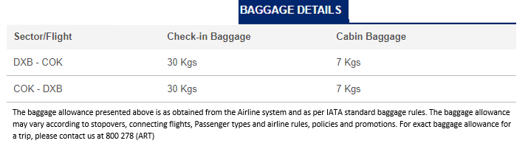 FIG 6.1 : Cabin and CheckinBaggage information

### 

# Search filters:

The search page should allow the user to filter their results by below mentioned criteria.

(Filters shall be frozen when the user scrolls down to the page.

Filter by Stops(Need “only” link against each option)

* Filter by Airlines(Need “only” link against each option)Filter by Duration
* Filter by Fare Type(refundable or non-refundable)Filter by Baggage

# Filter by Stops:

Option to filter by stops like Non-Stop, 1 Stop, 2+Stops. Need “only” link against each option.

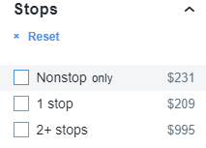

FIG 7.Filter by stops

# Filter by Airlines:

Option to filter by airlines.Need “only” link against each option.

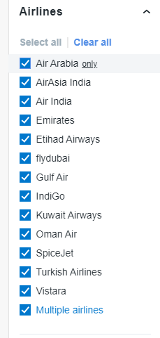

FIG 8. Filter by airlines

# Filter by Duration:

Option to filter by duration(lowest to highest)

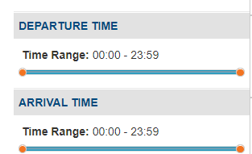

FIG 9.Filter by duration

# Filter by Fare Type:

Option to filter by Fare Type (Refundable and Non Refundable)

# Filter by Baggage:

Option to filter by baggage

# Sorting Method:

Need a sort drop down list on top of the search results to do sorting based on Price(low ;high), Duration(short ; long), Departure Earliest, Departure Latest, Arrival Earliest, Arrival Latest.

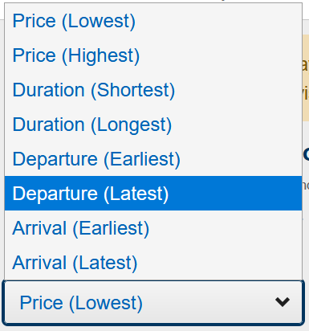

FIG 10. Sorting method

# REVIEW FLIGHT:

In search result page, after selecting particular flight the system will redirect to “review flight” page.

# Itinerary details

On the review page, the user will see the itinerary details as shown below. Along with this need to show Fare breakup details, Full Fare Rules link, Mini Fare Rules link and Baggage Details (Cabin/Check-in Sector wise).

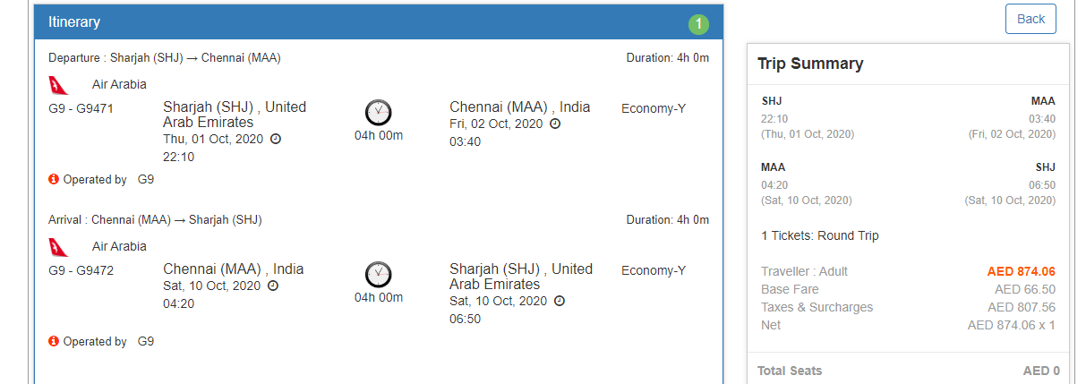

FIG 11. Itinerary screen

# Cabin Baggage:

By default, for all the GDS provided airlines the system shall show the cabin baggage as 7 Kgs per person. Refer the figure 14.

The same information “7 Kgs per person” shall be displayed in the itinerary review screen, booking confirmation screen and the ticket PDF.

On the itinerary review screen there is an information icon, when the user moves the cursor on top of the icon, the system shall show the message as “The baggage allowance presented is as obtained from the airline system and as per IATA standard baggage rules. The baggage allowance may vary according to stopovers, connecting flights, passenger types and airline rules, policies and promotions. To reconfirm exact baggage allowance for a trip, please contact us at 800278 (ART)”

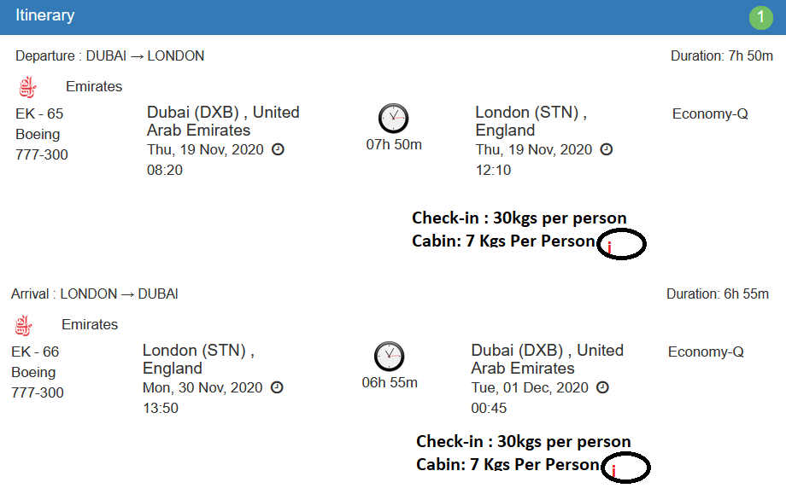

Fig 11.1: Cabin Baggage.

# Booking Flow:

# Guest User:

* + - If the user has come as a guest user, then in the Itinerary screen the user shall have two options (Continue as Guest or Login & Continue).
    - The user shall click the button Continue as Guest.
    - The user shall enter their Email and clicks the Continue.
    - The user shall add the Guest details and checks the terms and conditions and the clicks the Proceed button to go to the payment gateway screen. Refer Fig 8

# Logged In User (Login from the Home page).

* + - In this case, the user shall login from the home page.
    - The user enters the search criteria and clicks on the search button. The system shall send requests to the suppliers.
    - The system shall show the results
    - The user shall select the flight and in the flight booking review screen selects the flight and then proceeds to the itinerary details.
    - The user shall be able to create a new guest or if the user wants to add his/her details then the user shall select the option “Use my profile”.
    - Or if the user wants to book for his/her dependencies then the user shall select from my traveller profiles. The system shall show the dependencies profiles and the user shall add the guest to the booking.
    - The user shall add the Guest details and checks the terms and conditions and the clicks the Proceed button to go to the payment gateway screen.

# Guest User and Login from the Booking review screen:

* + - If the user has come as a guest user, then in the Itinerary screen the user shall have two options (Continue as Guest or Login & Continue).
    - If the user has a B2C User ID login and password, then the User shall click the Login & Continue. The system shall redirect the user to the login screen, the user shall enter the Username and password and then will be redirected to the Itinerary screen as a logged in User.
    - The user shall be able to create a new guest or if the user wants to add his/her details then the user shall select the option “Use my profile”.
    - Or if the user wants to book for his/her dependencies then the user shall select from my traveller profiles. The system shall show the dependencies profiles and the user shall add the guest to the booking.
    - The user shall add the Guest details and checks the terms and conditions and the clicks the Proceed button to go to the payment gateway screen.

# Insurance Upsell

Here the user will have an option to select their insurance plan. By default an insurance plan shall be selected (lowest one). The cost shall be added to the fare. The user shall opt out if insurance not required.

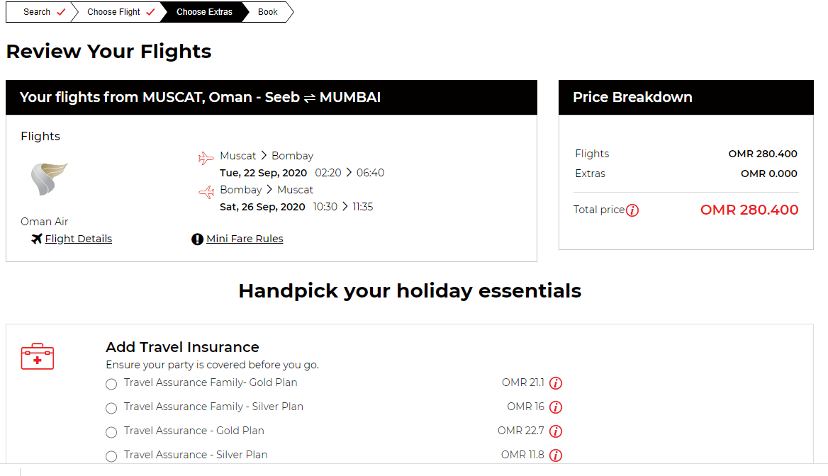

FIG 12. Insurance upsell

# Travellers

Here the user can enter their passenger details. This section should have fields as mentioned below

* Salutation
* Given Name
* Surname
* DOB
* Contact Number
* Email ID,
* National ID field to be enabled only for the Saudi Domestic sectors for Saudi Nationalities.
* Passport Number and Passport Expiry date (Passport Number and Passport Expiry date field should be enabled and mandated as per the segments. - Country level validation shall me enabled in phase 1 and passport requirements at airline level will be done in Phase 2, however based on ART request for below Airlines the mandatory passport information to be enabled in the systems by any means Pakistan - Pakistan Airline, Kuwait - Kuwait Airways, Saudi Arabia – Saudi Airline.

The Country – City-Airport mapping table may be used identify the either of the from or To Airports in an OW/RT/Multi search belongs to the specific table and mark for mandatory passport details. The transit cities may be avoided for this validation)

* The Passport required country list and Saudi Airports list identify Saudi Domestic travel is provided in the attached sheet.
* 

Provision to capture the Air miles Number in the Profile (Only Air-miles number shall be entered. No other details required. After the Traacs BO is integrated, we need to send the Air-miles number in the API to traacs). Airmiles is a 13 digit number. So validations we can keep as

- Only numbers allowed and it should be of 13 digit length

* Need an option to have Frequent Flyer (Number and Airline Selection),
* Meals Selection (Standard meals options to be available for selection—Only for GDS/LCC as per ancillary options available),
* Seat Preference (Aisle/Window options to be available for selection—Only for GDS),
* Special Services - Basinet (option to be available only for infants)

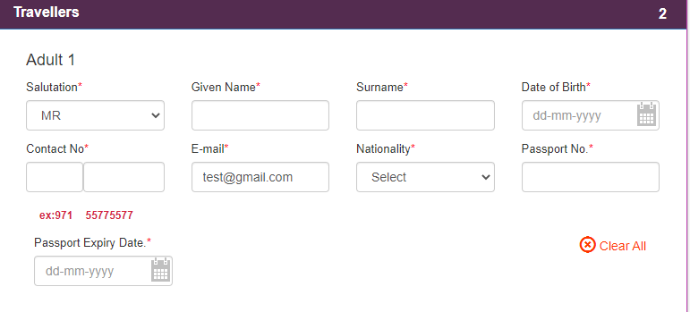

FIG 13.Traveller screen

The Country Code field should be as mentioned below

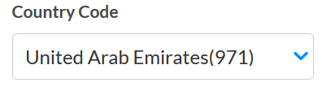

FIG 13.1. Country code

• The country name and code (in brackets)

• Data should be populated when the user types the country name or country code and the field should be drop down list as well.

# National ID for Saudi Nationalities:

* + For the Saudi Nationalities it is mandate to pass the National ID (also known as Imamate) in the booking request for the domestic journey within Saudi Arabia. This National Field should be enabled in the passenger creation only for the Saudi Nationals that too only when they are doing a domestic travel within Saudi Arabia. In the profile/travellers profile creation screen this will be non-mandatory field and the user can enter the National ID and save the profile.Refer Fig 5 and 6.
    - Scenario 1: The logged in user does a Saudi Arabia domestic travel search and in the passenger creation area (during the booking journey) selects the option Use my Profile or Select the traveller from the dependency list and the profile is saved with Saudi National ID, then the system shall auto-populate the Saudi National ID and then sends the ID in the booking request. The field shall be mandatory and editable as well.
    - Scenario 2: The logged in user does a Saudi Arabia domestic travel search and in the passenger creation area (during the booking journey) selects the option Use my Profile and the profile doesn’t have the Saudi National ID, then the system shall make the Saudi National ID field as blank and mandatory. The user enters the ID and then sends the ID in the booking request.
    - Scenario: If it is a new passenger, then the Saudi National field will be blank and mandatory for the user to enter the data for Saudi Nationals.
    - Need a provision to accept Saudi national ID during profile creation.
    - May create a country-City master with cities/Airports within Saudi to track whether the travel is within Saudi when Nationality is Saudi. ( ART need to provide city/airport data and needs to provide when new cities/airports operational for flights – Attached city sheet)
  + Commands in Sabre:3DOCS/C/I/12453265/SA/02AUG80/M/21JUN22/RIYAZ/MOHAMED-1.1

Same as api like ppt .for pasport the entry 3docs or 4docs foaaie 3docs/p . For others as below "p " to be changed to I. “I - National ID”

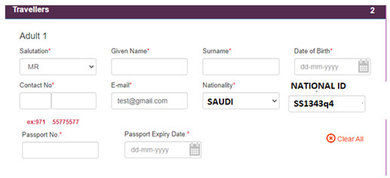

Fig 13.2: Passenger creation (booking journey)

# Provision to capture the Air miles Number in the Profile:

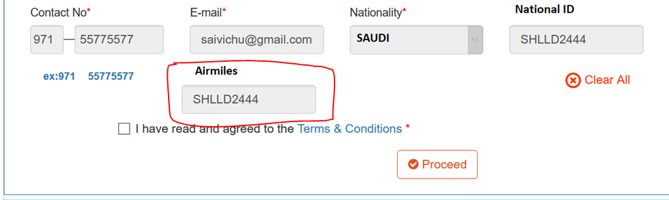

# Special Services Request for GDS Flights:

The following SSR options shall be available for each passenger creation.

* Meals Selection (Standard meals options to be available for selection—Only for GDS)
* Seat Preference (Aisle/Window options to be available for selection—Only for GDS)
* Special Services - Basinet (option to be available only for infants)
* In the Profile area Passenger has option to set his preferences for meal, seat and can update frequent flyer numbers. If passenger has already updated his preferences then that information would be picked by and displayed , the same information will go in the xml

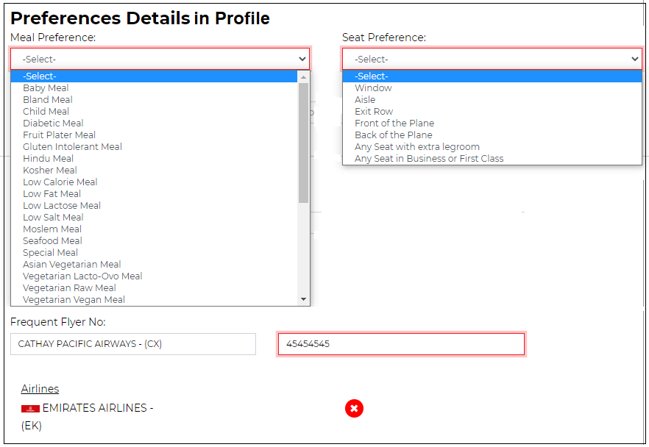

* Against each service an Information icon (i) shall be available. Refer figure 13. When the user points the cursor on top of the icon the system shall show the message as “The request shall be submitted to the Airlines. Please contact our call centre or the Airlines for confirmation”.
* In the itinerary confirmation page and in the ticket copy below the flight details the below information shall be details only if the respective request has been submitted.
  + Example 1: Meal Request has been submitted to the Airlines. Please contact our call centre or the Airlines for confirmation
  + May be a Request drop down per passenger with Meal types availalble in GDS and the request will go to GDS as a service request

CODE EXPLAINATION

AVML ASIAN VEGETARIAN MEAL

BBML INFANT/BABY FOOD

BLML BLAND MEAL

CHML CHILD MEAL

DBML DIABETIC MEAL

FPML FRUIT PLATTER

GFML GLUTEN-FREE MEAL

HNML HINDU (NON VEGETARIAN) MEAL

JPML JAPANESE MEAL (LH SPECIFIC)

KSML KOSHER MEAL

LCML LOW CALORIE MEAL

LFML LOW CHOLESTEROL/LOW FAT MEAL

LSML LOW SODIUM, NO SALT ADDED

MOML MOSLEM MEAL

NFML NO FISH MEAL (LH SPECIFIC)

NLML NON LACTOSE MEAL

OBML JAPANESE OBENTO MEAL (UA SPECIFIC)

ORML ORIENTAL MEAL

RVML RAW VEGETARIAN MEAL

SFML SEA FOOD MEAL

SPML SPECIAL MEAL, SPECIFY FOOD

VGML VEGETARIAN MEAL (NON-DAIRY)

VLML VEGETARIAN MEAL (LACTO-OVO)

VOML VEGETARIAN ORIENTAL MEAL

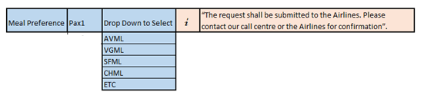

* + Example 2: Seat Request has been submitted to the Airlines. Please contact our call centre or the Airlines for confirmation( May be a Request drop down per passenger with seat type options as Window seat, Aisle seat and the request will go to GDS as a service request)

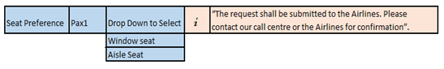

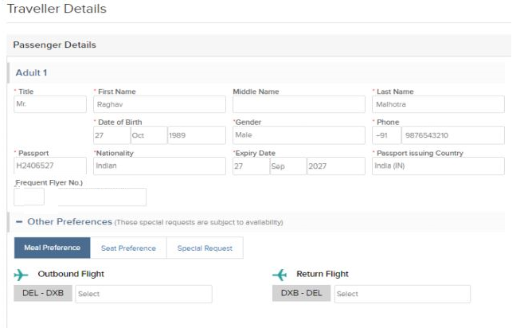

* + Example 3: Basinet Request has been submitted to the Airlines. Please contact our call centre or the Airlines for confirmation

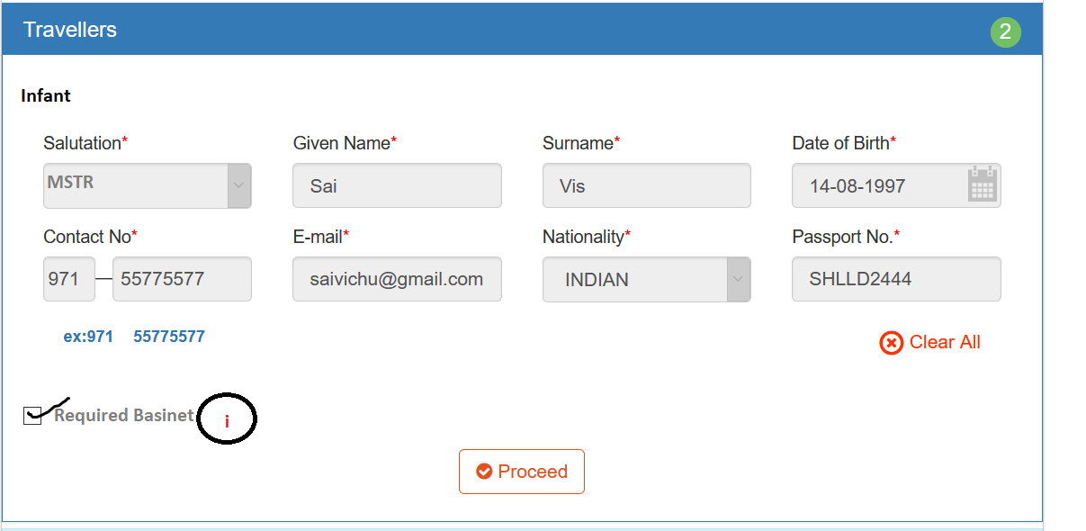

Fig 13.3 : BASINET SELECTION

Though Basinet required tick box marked against the infant while sending the BSCT request, it has to be attached to the 1st Adult passenger in the PNR

Meal and Seat are per pax and Basinet option for Infant and shall be linked to the Lead Passenger in the PNR.

# Special Services Request for LCC Flights

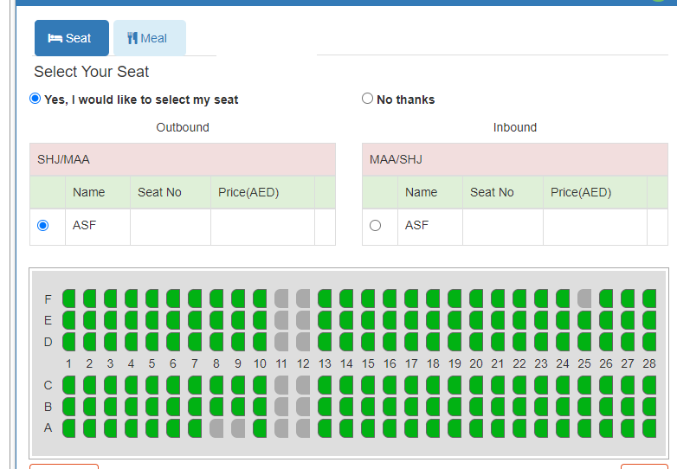

FIG 13.4 SEAT SELECTION

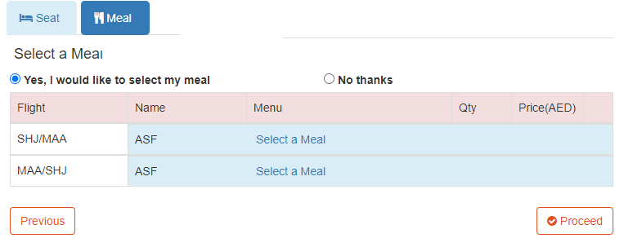

FIG 13.5 MEAL SELECTION

After clicking on select a meal, below mentioned screen will open where user can select a meal. On clicking particular the user can add the quantity as mentioned in FIG 13.6 MEAL QUANTITY

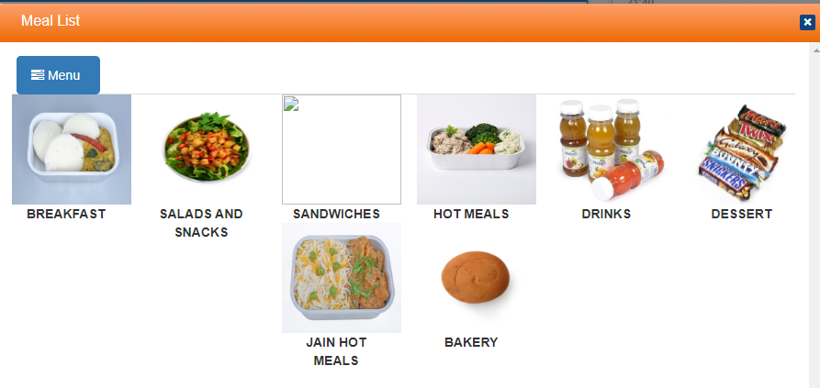

FIG 13.6 MEAL DETAILS

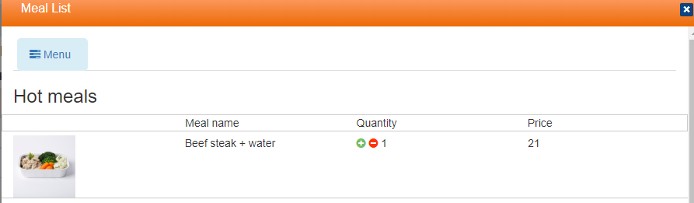

FIG 13.7 MEAL QUANTITY

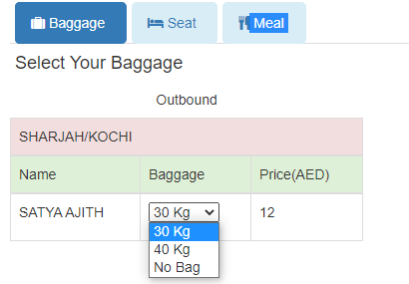

FIG 13.8 BAGGAGE SELECTION

# Trip summary

Trip Summary panel should be frozen state. So that when the user scrolls down the page till the payment screen this information shall be displayed.

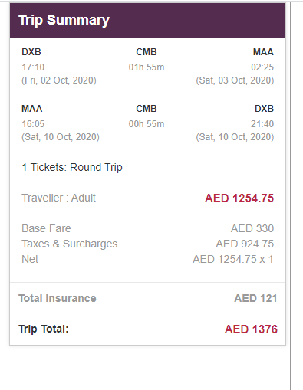

FIG 14 Trip summary

# Payment

This section allows the user to pay for their booking by providing their card details and proceed with pay.

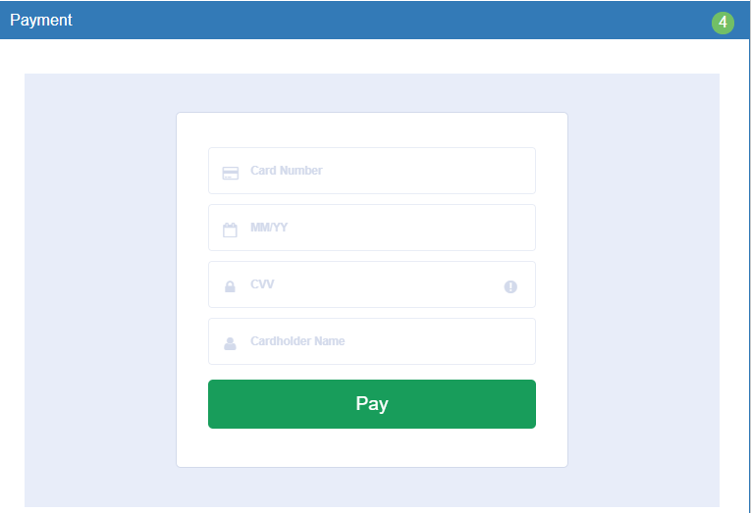

FIG 15 Payment screen

# Payment And Booking Confirmation Process:(GDS)

* + - The user shall enter the credit card details and then clicks the pay button.
    - The user shall be redirected to the payment gateway system to confirm the payment.
    - Meanwhile, the system sends the PNR booking request to GDS and confirms the booking by creating a PNR.
    - Once the payment is successful (blocking and settlement) then the ticketing request is sent to the GDS.
    - Once the booking is confirmed from the supplier end, then the system shall redirect to the booking confirmation page and also the voucher will be sent automatically to the user’s email ID. In the booking confirmation screen there will be an option for the user to send the voucher through email option.

# Process Flow:

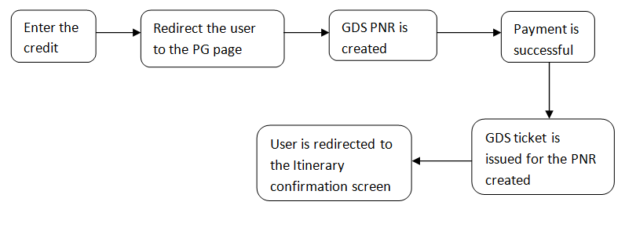

# Payment And Booking Confirmation Process:(LCC)

* + - The user shall enter the credit card details and then clicks the pay button.
    - The user shall be redirected to payment gateway page to confirm the payment
    - The payment will be blocked and booking request for creating PNR will be sent to LCC
    - On the successful booking, the payment will be settled and the user will be redirected to booking itinerary page.

# Successful booking scenario:

|  |  |  |  |  |  |
| --- | --- | --- | --- | --- | --- |
| S.No | Service | Action 1 | Action 2 | Action 3 | Action 4(Queue- mid office system) |
| 1 | Flight- GDS Booking | Redirected to the Itinerary Confirmation screen | Itinerary Email Confirmation (with Ticket PDF) Sent to the Customer | Itinerary Copy Email sent to the Reservation team. | The successful booking will be updated in the queue. |
| 2 | Flight-LCC Booking | Redirected to the Itinerary Confirmation screen | Itinerary Email Confirmation (with Ticket PDF) Sent to the Customer | Itinerary Copy Email sent to the Reservation team. | The successful booking will be updated in the queue. |
| 3 | Flight (GDS) + Insurance | Redirected to the Itienrary Confirmation screen | Itinerary Email Confirmation (with Voucher PDF) Sent to the Customer | Itinerary Copy Email (with Voucher PDF) Sent to the Reservation Team | The successful booking will be updated in the queue. |
| 4 | Flight (LCC) + Insurance | Redirected to the Itienrary Confirmation screen | Itinerary Email Confirmation (with Voucher PDF) Sent to the Customer | Itinerary Copy Email (with Voucher PDF) Sent to the Reservation Team | The successful booking will be updated in the queue. |

# Failure case:

|  |  |  |  |  |  |  |
| --- | --- | --- | --- | --- | --- | --- |
| S.No | Service | Reason | Action 1 | Action 2 | Action 3 | Action 4(Queue- mid office system) |
| 1 | Flight- GDS Booking | Payment Failed- PaymentFulfilment ( Block+Auth Failure) – PNR created. | At this point, the system shall redirect the user to the booking review screen with the PNR details and the relevant error shown in the screen. The user can retry the payment again for 5 times. More than 5 times, system shall not allow the user for the payment and instead it show a message to call the call centre. | Customer shall receive a payment failure email and in the email should show system booking reference number and the ticketing limit, before the ticketing time limit the customer should call the call centre. | System should send an email notification with the Passenger details (Name, Email ID, Contact number (Country code+Phone number), PNR,Total fare to the call centre team or reservation team to take further actions. | Queue shall be available for each failure against that PNR with the status and group together under the PNR. The payment from the customer shall be collected through other means. And after a successful payment the system shall update the queue as Payment successful and then booking status shall also be changed under My booking for the customer as Successful. |
| 2 | Flight- GDS Booking | Payment Successful-Ticketing Failed (PNR created, PG block+Auth success, Ticketing failed) | At this point redirect the customer to the booking confirmation screen with PNR details and NI reference number but no payment gateway enabled with a customized message. Ticket number shall not be available. | Customer receive a customized Email stating booking and payment is successful. But ticket is not issued. | System should an email notification with the Passenger details (Name, Email ID, Contact number (Country code+Phone number), PNR, PG Transaction ID,Total fare, and the ticketing limit to the call centre team or reservation team to take further actions. | Queue shall be available for the failure against that PNR with the payment status as Sucess. The staff shall retrieve the PNR from the B2B system/GDS and issue the ticket. Then the staff shall update the status as ticketed for the PNR in the queue and put the status as Successful. then booking status shall also be changed under My booking for the customer. After updating the queue, the system shall send the ticket copy to the customer from the B2B system. |
| 3 | Flight-LCC Booking | Payment Failed- Payment Blocking Failure (No PNR created and PG Blocking is failed) | The system shall redirect the user to the booking review screen with the relevant error shown in the screen. The user can retry the payment again for 5 times. More than 5 times, system shall not allow the user for the payment and instead it show a message to call the call centre. | Customer shall receive a payment failure email, stating the reason and try with payment methods. | System should an email notification with the Passenger details (Name, Email ID, Contact number (Country code+Phone number), and itinerary to the call centre team or reservation team to take further actions to assist Passenger and make the sale happen The booking related information will be updated in the queue as On request booking. | The booking related information will be updated in the queue as On request booking. |
| 4 | Flight-LCC Booking | PG Blocking successful but Booking failed | Redirected to the booking review screen showing the error that is related to the supplier.` | Customer shall receive an email on the payment success and about booking failure. | System should an email notification with the Passenger details (Name, Email ID, Contact number (Country code+Phone number), booking scenario details (sector, trip type, date of journey).Total fare to the call centre team or reservation team to take further actions. | The support staff shall go check the NI portal and see if the amount is blocked or not. The staff then shall call the client to reconfirm the scenario and complete the booking either from B2B or from the supplier portal. Then the staff shall will authorize the payment from the NI portal. Update the status of the booking from the queue. then booking status shall also be changed under My booking for the customer. If the customer doesnt want to confirm the booking or the support person is not able fullfill the booking, then the staff shall reverse the amount from NI portal that is blocked. The staff shall then update the status as cancelled from the Queue and immediately the system shall send an email to the customer stating that " The amount has been reversed to your account. For more details please contact your bank". |
| 5 | Flight-LCC Booking | PG Blocking successful, booking successful, PG Auth failed. | Redirecting to a page where the system shall the system reference number and show the message as "Your seat has been blocked, Awaiting for the payment confirmation from the bank. We will get in touch with you as soon as possible". | Customer shall receive an email on the seat blocking and the pending payment status. | System should an email notification with the Passenger details (Name, Email ID, Contact number (Country code+Phone number), PNR. Total fare to the call centre team or reservation team to take further actions. Severity high. | The support staff shall go check the NI portal and see if the amount is blocked or not. The staff then shall authorize the payment. The staff shall update the queue from pending to success. Once this is done, then the B2B system shall send the ticket copy through email to the client. And in the my booking the status shall also be updated as success. |
| 6 | Flight (GDS) + Insurance | Payment Failed- Payment Fullfillment (Block+Auth Failure-(PNR created and no insurance booked) | PNR is created, the system shall redirect the user to the booking review screen with the PNR details and the relevant error shown in the screen. The user can retry the payment again for 5 times. More than 5 times, system shall not allow the user for the payment and instead it show a message to call the call centre. | Customer shall receive a payment failure email and in the email should show system booking reference number and the ticketing limit, before the ticketing time limit the customer should call the call centre. | System should send an email notification with the Passenger details (Name, Email ID, Contact number (Country code+Phone number), PNR, Insurance Plans, Total fare to the call centre team or reservation team to take further actions. | Queue shall be available for each failure against that PNR with the status and group together under the PNR and insurance plan. The payment from the customer shall be collected through other means.and after a successful payment the system shall update the queue as Payment successful and then booking status shall also be changed under My booking for the customer as Successful. |
| 7 | Flight (GDS) + Insurance | Payment Successful- (PNR created, PG block+Auth success, Ticketing Successful, Insurance booking failed | Redirected to the booking confirmation screen with the Flight details and for the Insurance, need to show the message the Insurance plan willl be confirmed shortly. | Customer shall receive the ticket copy email and for the Insurance, need to show the message the Insurance plan will be confirmed shortly. | System should an email notification with the Passenger details (Name, Email ID, Contact number (Country code+Phone number), PNR, PG Transaction ID, Insurance plan selected to the call centre team or reservation team to take further actions. | The support staff shall go check the NI portal and see the payment status. if it is successful, the support person will do an insurance booking either from B2B or from the supplier portal. Update the status of the booking from the queue. then booking status shall also be changed under My booking for the customer. |
| 8 | Flight (LCC) + Insurance | Payment Failed- Payment Blocking Failure (No PNR and insurance plan created) | the system shall redirect the user to the booking review screen with the relevant error shown in the screen. The user can retry the payment again for 5 times. More than 5 times, system shall not allow the user for the payment and instead it show a message to call the call centre. | Customer shall receive a payment failure email, stating the reason and try with payment methods. | System should an email notification with the Passenger details (Name, Email ID, Contact number (Country code+Phone number), and itinerary to the call centre team or reservation team to take further actions to assist Passenger and make the sale happen The booking related information will be updated in the queue as On request booking. | The booking related information will be updated in the queue as On request booking. |
| 9 | Flight (LCC) + Insurance | PG Blocking successful but LCC Booking Failed (If LCC booking failed, no insurance booking request shall be sent) | Redirected to the booking review screen showing the error that is related to the supplier.` | Customer shall receive an email on the payment success and about booking failure. | System should an email notification with the Passenger details (Name, Email ID, Contact number (Country code+Phone number), booking scenario details (sector, trip type, date of journey), Insurance plan selected, Total fare to the call centre team or reservation team to take further actions. | The support staff shall go check the NI portal and see if the amount is blocked or not. The staff then shall call the client to reconfirm the scenario and complete the booking either from B2B or from the supplier portal for both LCC and Insurance. Then the staff shall will authorize the payment from the NI portal. Update the status of the booking from the queue. then booking status shall also be changed under My booking for the customer. If the customer doesnt want to confirm the booking or the support person is not able fullfill the booking, then the staff shall reverse the amount from NI portal that is blocked. The staff shall then update the status as cancelled from the Queue and immediately the system shall send an email to the customer stating that " The amount has been reversed to your account. For more details please contact your bank". |
| 10 | Flight (LCC) + Insurance | PG Blocking successful, booking successful, PG Auth failed. | Redirecting to a page where the system shall the system reference number and show the message as "Your seat has been blocked, Awaiting for the payment confirmation from the bank. We will get in touch with you as soon as possible". | Customer shall receive an email on the seat blocking and the pending payment status. | System should an email notification with the Passenger details (Name, Email ID, Contact number (Country code+Phone number), PNR, Insurance plan, Total fare to the call centre team or reservation team to take further actions. | The support staff shall go check the NI portal and see if the amount is blocked or not. The staff then shall authorize the payment. The staff shall update the queue from pending to success. Once this is done, then the B2B system shall send the ticket copy and insurance copy through email to the client. And in the my booking the status shall also be updated as success. |

# Booking Confirmation Page:

In the booking confirmation page the following information shall be listed.

* + - Cancellation Policies of ART
    - Contact Details of ART
    - Option to send the email/print

# Approval

|  |  |  |
| --- | --- | --- |
| Prepared by | Signature | Date |
| Sangeetha  Convergent Technology Solutions |  |  |
| Approved by | Signature | Date |
|  |  |  |